DGLL HELP DOCUMENT
How to approve/reject a Notice of Approach

When you receive a DGLL notification about a Notice of Approach

Login to your DGLL Account via https://www.dgll.leaguesystem.co.uk/procedures/club/index.php

Select “ Player Transfer Request” in the top bar

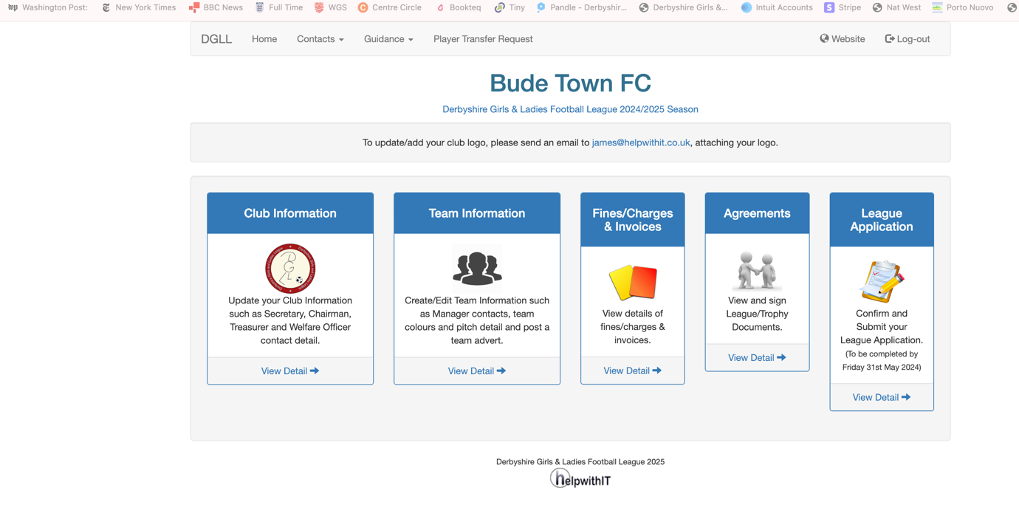

Select the “Approach Received” button, then select the View button

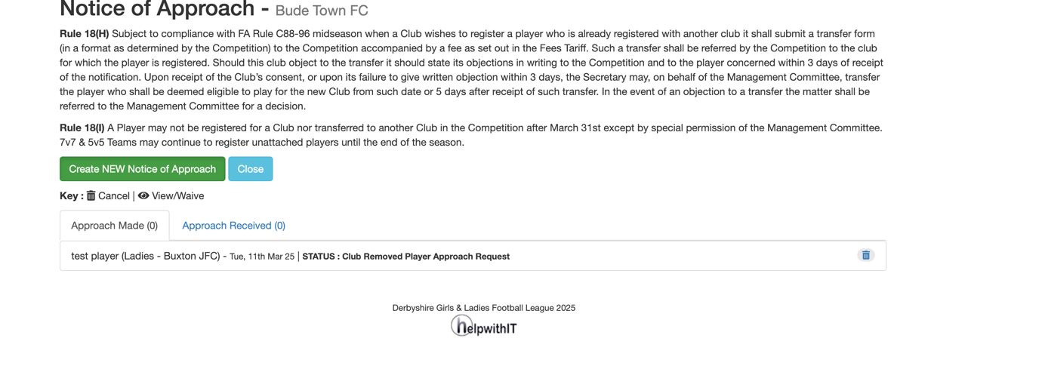

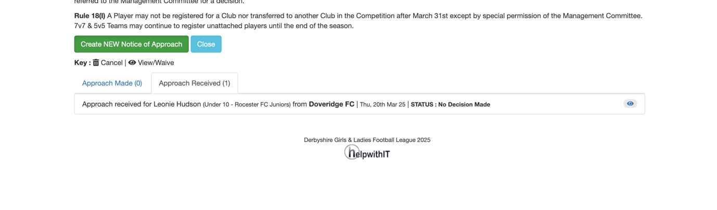

Complete the form by selecting one of the 3 options

The Select “Update”

The DGLL will process the transfer or, if you refuse the Transfer , will contact you directly for further information.

