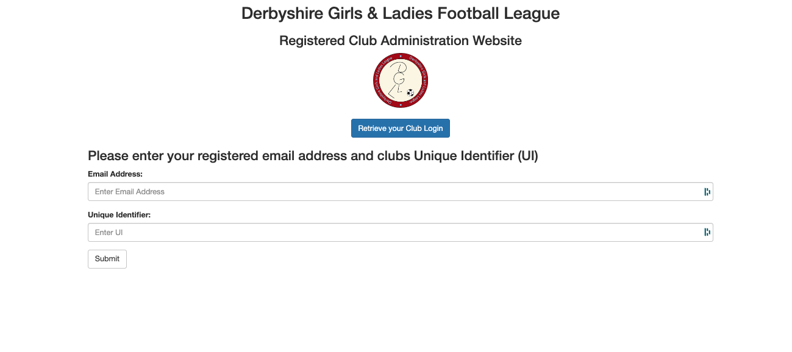
NEW CLUBS
PLEASE COMPLETE THIS ONLINE DOCUMENT IMMEDIATELY TO APPLY FOR MEMBERSHIP

EXISTING CLUBS
PLEASE COMPLETE THIS INFORMATION BEFORE 31/5/25, YOUR MEMBERSHIP IS AUTOMATICALLY APPROVED UNDER FA RULES

To Login to the League Management System enter your e mail address and the unique identifier sent to your e mail https://www.dgll.leaguesystem.co.uk/procedures/club/index.php

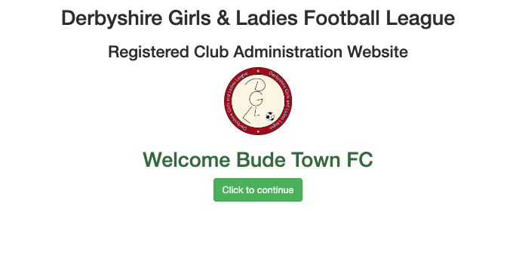

Click to Continue

To upload your Club Logo please submit an e mail to james@helpwithit.co.uk

With a copy of your logo, plus club name & league you are playing in.
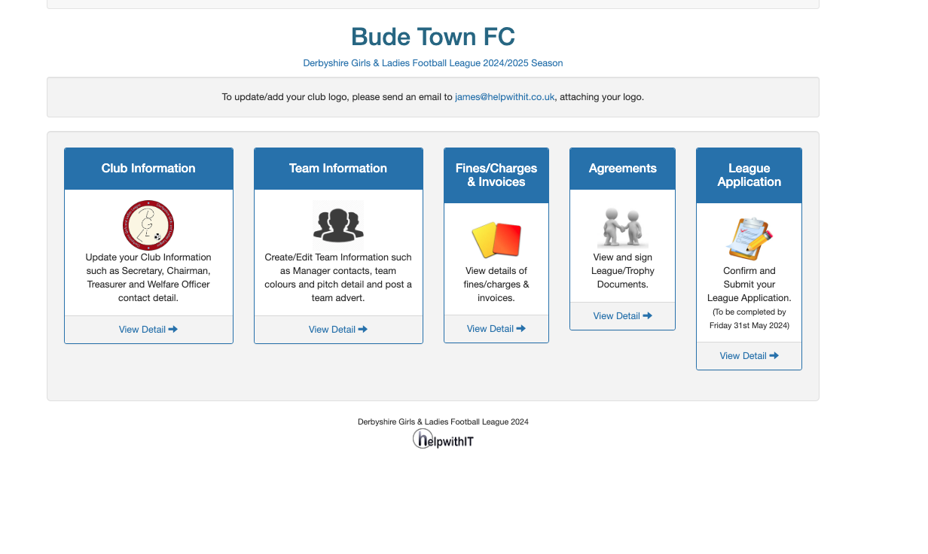

You will be presented with 5 menus which need working through from left to right.

Click CLUB INFORMATION

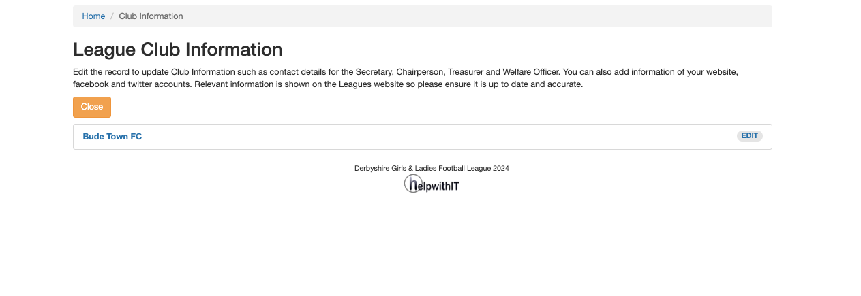

Click Edit
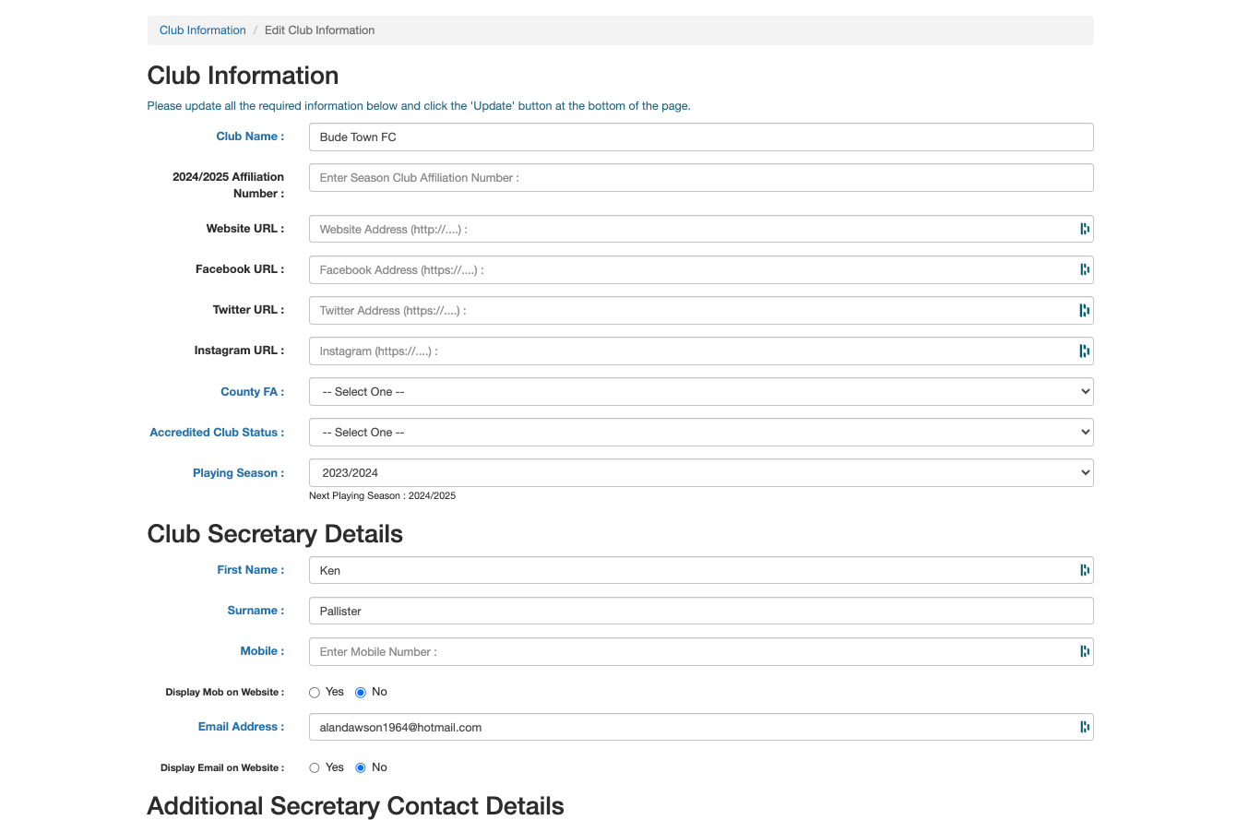

Complete the information and click update. Please note the County FA defaults to Derbyshire only.

Change the playing season to 25-26.

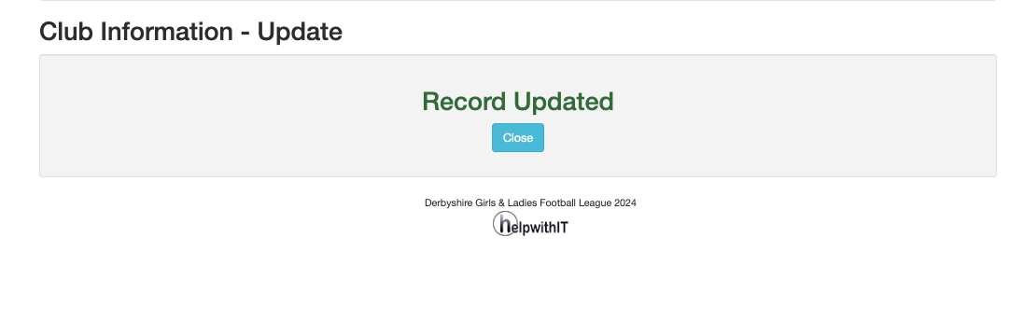

Next Select Team Information on the Home page, you will be presented with a list of your current teams.

Select Edit, make edits to the current team to reflect season 25-26. Change Season Year & Age group, enter team nickname etc.

Edit any coach info & input team colours and select venue or create a new one.

Select Update

To Create any New teams as required, click create new team. To remove a team, follow the details on the “Show Example” button.

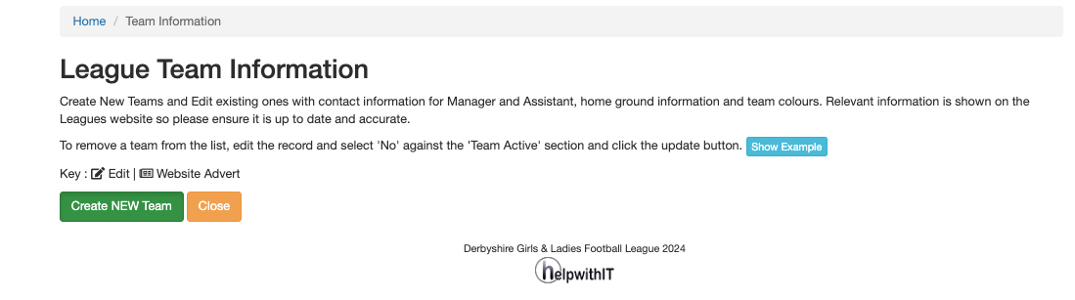

Back at the home page, select agreements, and complete the form which will automatically be completed with your secretary & chairs names. Select Agree and confirm.
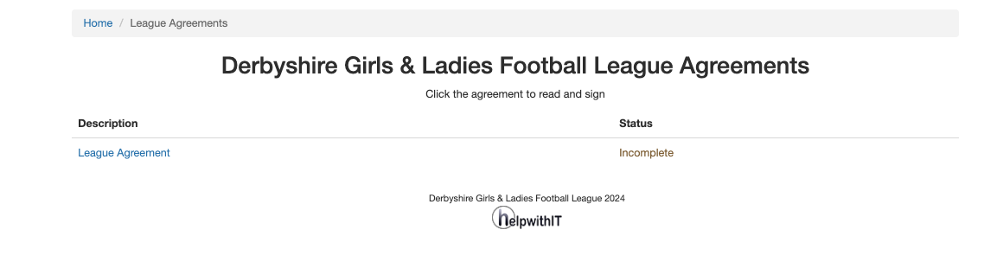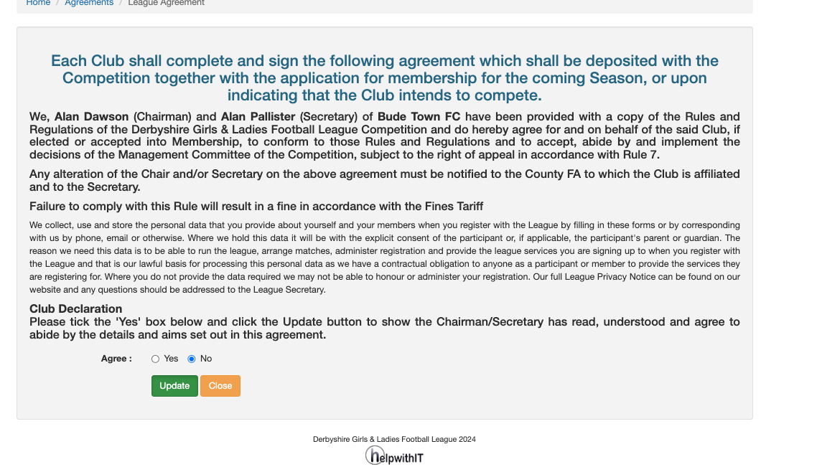

Back to the Home Page select Application and confirm the application.

PLEASE NOTE
The DGLL has already processed the invoices for existing teams for season 25-26, this process is to provide the correct information for the Club & Teams ONLY as well as having a digital copy of the League Agreement.

New Clubs will be billed separately on application.

Your Secretary & Treasurer will receive an e mail outlining the teams entered for the coming season, like the copy shown below. (please note the page shown will state season 25-26)

You can add teams at any point in the future, the league secretary is automatically notified.

